CAFT Settlement Process
Purpose: To ensure the settlement amount CWB owes CUPS or CUPS owes CWB is balanced to the CAFT files that settle daily. The settlement amount is for both Debit and Credit CAFT files.
The Settlement Report will also indicate if there are any files that have rejected.
- Debit Files Reject to : CAD 10970
- Credit Files Reject to : CAD 10971

Each day CUPS will send an email to CMS that will give the CAFT settlement amount for the previous day files. The email will state whether CUPS owes CWB or CWB owes CUPS.
- Print the email
Sign into T24 and print the ‘Overdrawn Accounts’ report
- 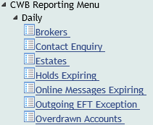
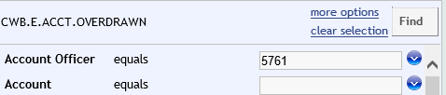
- Click on ‘Find’
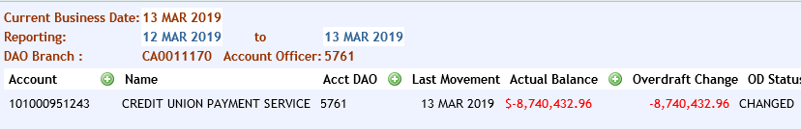
- The amount in the ‘Overdraft Change’ section needs to match the amount in the email
Print Report
- Note: When the email states that CUPS owes CWB, there will be no report in T24 to print

Searching for Settlement Report in T24
In T24 click on the following links highlighted in red below:
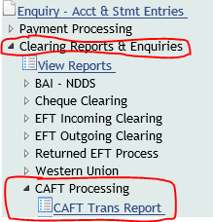
In the ‘Process. Date’ enter today’s date. On Monday’s enter Saturday’s date
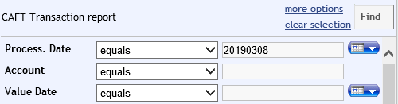

Upon retrieval of report, go to the last page :
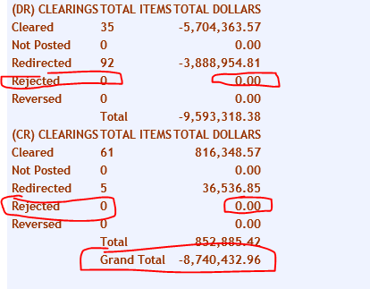
- Note: ‘Grand Total’ should be the same as the amount in the email from CUPS
Rejected items, ensure the total is zero. If there is an amount see below

When the ‘Grand Total’ is a negative balance, this means that CWB owes CUPS. A settlement entry must be posted.
- Copy this page onto a word document
- Write out the posting string:
- Dr CAD 10286 (effective one business day back) $ (Amount) Cr 101000951243 (effective on business day back)
- Post
- Initial document. This must be reviewed and approved by another CMS member
These entries must bring both accounts to a zero balance.

Rejected Items
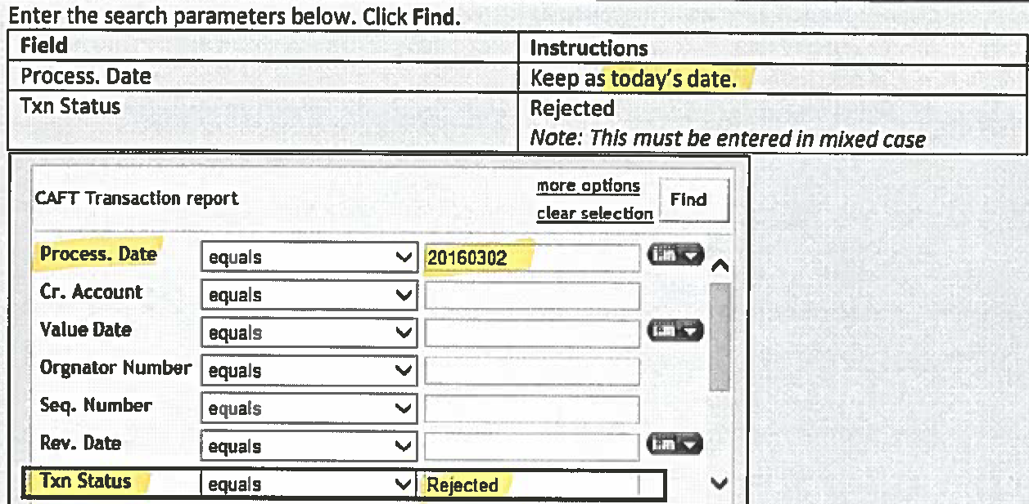
- Print page showing rejected items
- Note reason for item(s) being rejected

Posting examples of rejected items:
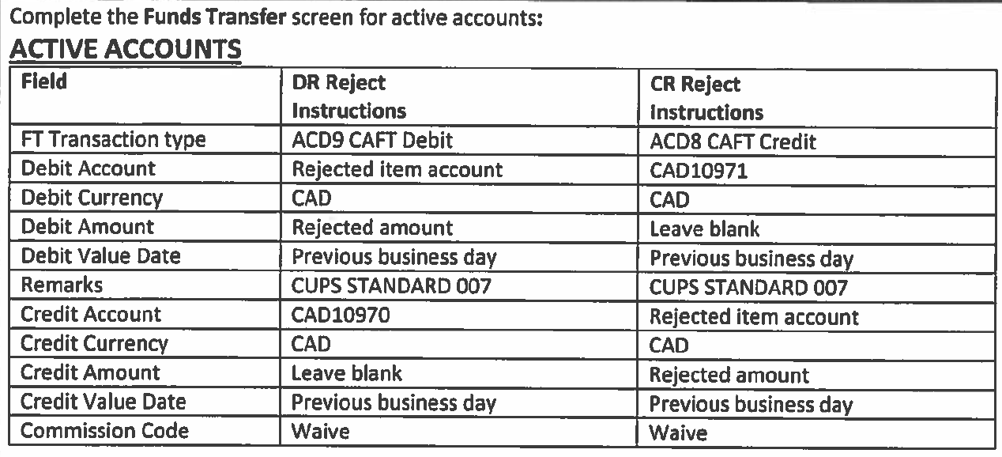

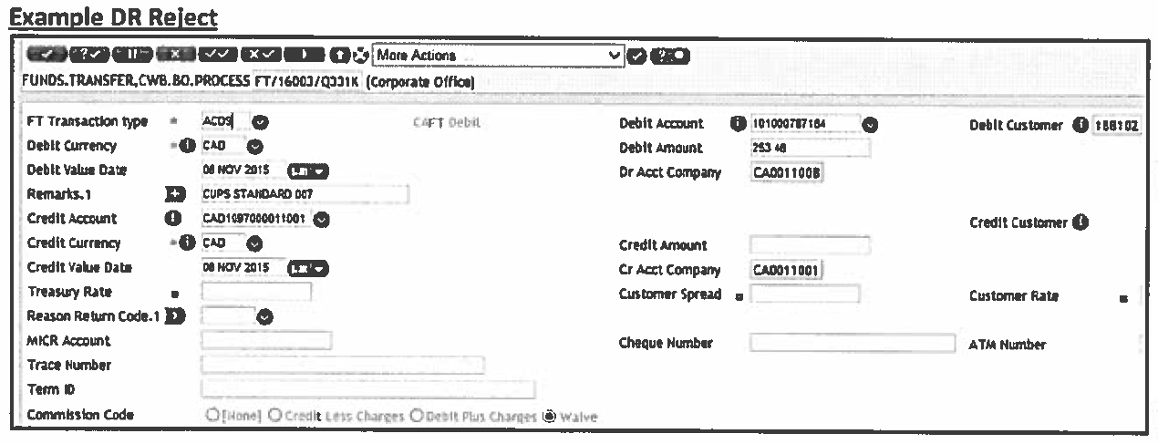
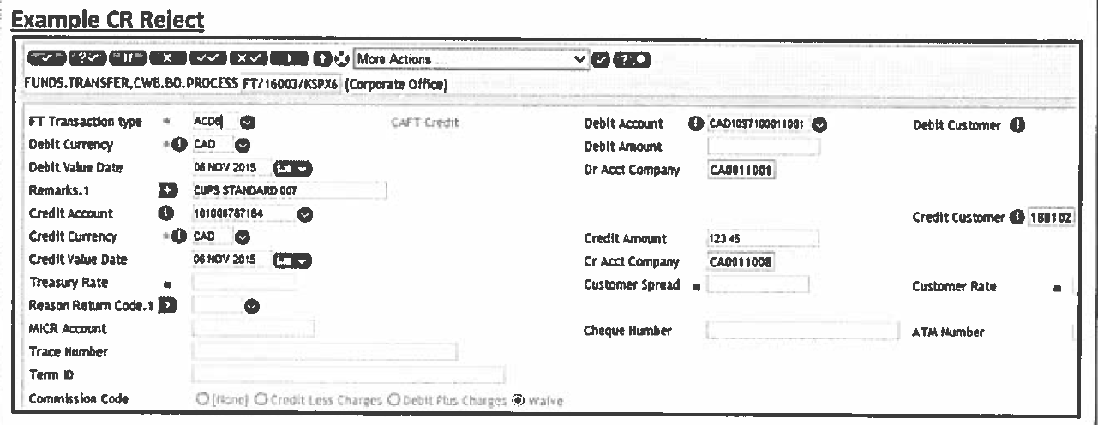
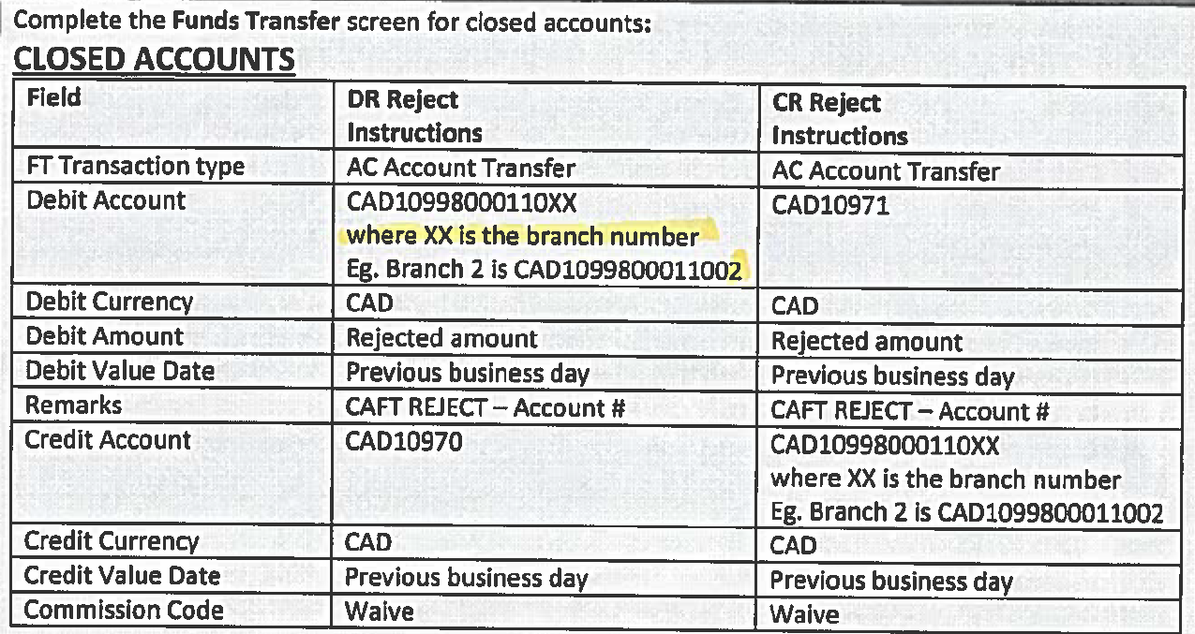

Beginning of Month Process

Due to National Leasing needing to settle day of, a wire is sent from CUPS to National Leasing. An email containing the wire amount is sent to CMS.
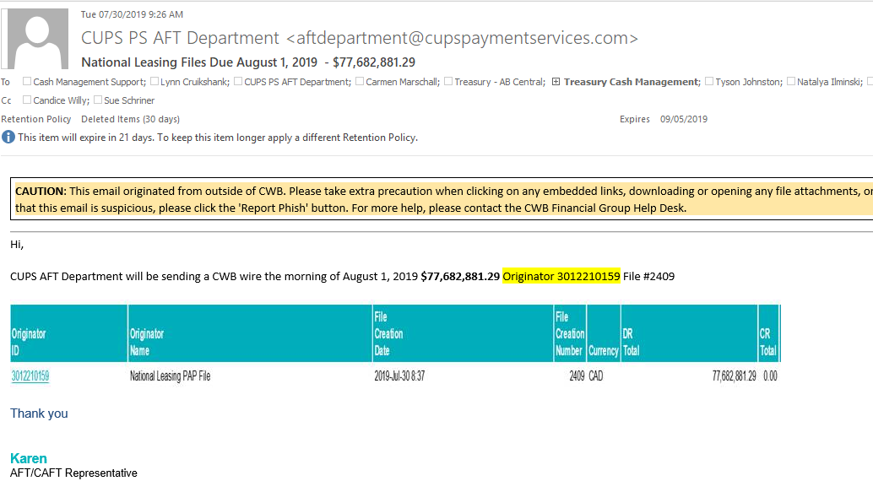

- The process does not change
- The only change is how we pull the CAFT Trans Report in T24
- You will notice the CAFT Trans report end balance will be the same value as the email sent from CUPS
- When in the CAFT Trans Report , do as ‘Save As’
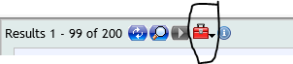
- When the excel report opens, go the end of the report and next to the final value, enter the amount of National Leasing wire plus amount in the CUPS email. The total of these 2 amounts should equal the end value found on the CAFT Trans Report
- Copy and paste the CUPS Trans Report on a word doc, like normal process
- Proceed as normal

